Перечень тем и заданий на 21.04.2020
 | Предмет | Тема для изучения  Классная работа | Домашняя работа
1. | Биология | Тема: Позвоночные животные  §22 стр.88-93 (повторить)  https://www.youtube.com/watch?time_continue=559&v=QH6PXlbnvA4&feature=emb_logo  https://resh.edu.ru/subject/lesson/460/ | Просмотреть видео-урок. Выполнить упражнения и задачи, а также проверочные работы в тетради с сайта https://resh.edu.ru/subject/lesson/460/
2. | Математика | Тема: Анализ контрольной работы  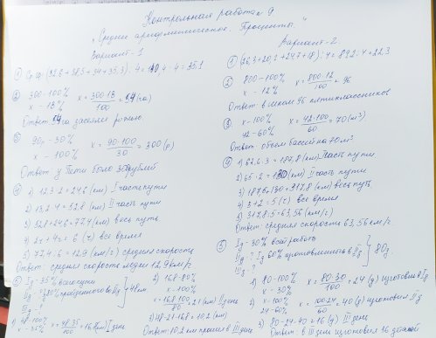  Выполнить работу над ошибками в тетради | № 1079, 1082  ( Работать с вариантами ВПР)
3. | Английский язык | Тема: Не пропустите! Контроль чтения. Стр.110  1)Записать число  Tuesday, the fourteenth of April.  Class work.  2)https://resh.edu.ru/subject/lesson/7513/main/268257/  3)Записать в словарь слова  4) Выполните контроль чтения №3. | Homework  1 ) выучить слова в словаре
5 класс Контроль чтения №3.
Фамилия,имя______________________________________Дата___________

Moscow Zoo
1. Tigers, monkeys, snakes and fish in the centre of the Russian capital! These animals all live in the Moscow Zoo, one of the largest in the world. It is the home for over 7000 different kinds of animals. The zoo also has got many exotic animals and birds. Get a map to make sure you see everything.
2. First, visit the Animal Island. There you can see the Amur Tigers, the white snow leopard, the Himalaya bears, the Asian lions and even an Australian emu. There you can also see colourful fish in large aquariums.Don’t miss the Night World exhibition too. This is a great chance for you to see the night animals.
3. All the young visitors must see the Children’s Zoo. Children can see the heroes of fairy-tales: the three piglets, the wolf and seven young goats and many other animals. There are also cafés and picnic areas. Kids can visit playgrounds. You will not forget the day in the Moscow Zoo!
- Подберите заголовки к абзацам.
a) For young visitors b) About Moscow Zoo c) Animals.
- Отметьте предложения T (true), F (false), DS (doesn’t say)
- Moscow Zoo is in London.___________
- You can see dancing Himalaya bears.__________
- There are a lot of exotic animals in the Zoo.____________
- There are only lions and tigers on the Animal Island.______________
- Colourful fish live in large aquariums.________________
- Australian emu is 2 metres tall.__________________
- Расположите предложения в логическом порядке, перепишите их.
- There are many heroes of Russian fairy-tales in the Children Zoo.
- Moscow Zoo is in the centre of the Russian capital.
- On the Animal Island, you can see tigers, leopards and other animals.
- Moscow Zoo is one of the largest in the world.
- You can watch the life of night animals in the Night World exhibition.
- You will spend a perfect day here.
- Найдите в тексте английские эквиваленты:
- в мире________________________________
- разноцветные рыбы____________________________________
- игровые площадки_____________________________________
- возьмите карту________________________________________
- трое поросят___________________________________________
- разные виды животных_______________________________________

4. | Русский язык | Тема: Дополнение.  § 66  Изучить теоретический материал.  Упр. № 511(устно)  Упр. № 512 (письменно)  Видеоурок  https://newsvideo.su/education/video/26973  https://www.youtube.com/watch?v=Jcykvq7NH1A
5. | Литература | Тема: Из зарубежной литературы (11 ч.)  Даниэль Дефо. Слово о писателе.  https://www.youtube.com/watch?v=_Z1Qf5ehFgk  https://www.youtube.com/watch?v=rvJAw-iTGms | Конспект.
6. | Внеурочная деятельность «Занимательная биология» | Добывание картофельного крахмала  https://yandex.ru/video/preview/?filmId=9997790923572041984&text=Добывание+картофельного+крахмала+биология

