Speaking №3 10th form
These are photos from your photo album. Choose one photo to describe to your friend.
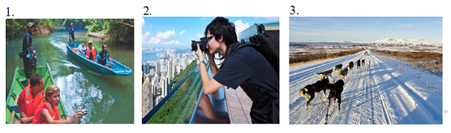
You will have to start speaking in 1.5 minutes and will speak for not more than 2 minutes (12–15 sentences). In your talk remember to speak about:
• where and when the photo was taken
• what/who is in the photo
• what is happening
• why you keep the photo in your album
• why you decided to show the picture to your friend
You have to talk continuously, starting with: "I’ve chosen photo number … ".

